SpringBoot:Caching with Redis

<https://www.youtube.com/watch?v=Yjm-izEb7TM>

Redis is a open-source in-memory data structure store which can be used as a database or a cache store or a message broker.

We will use it as a cache store.

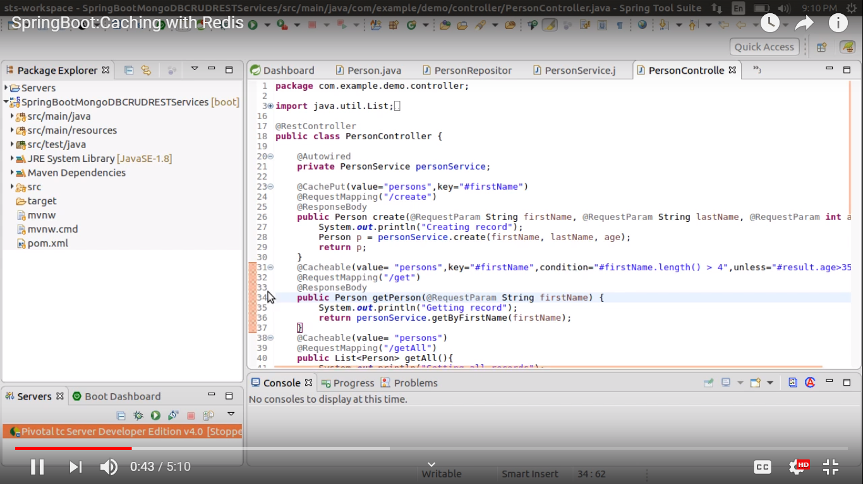

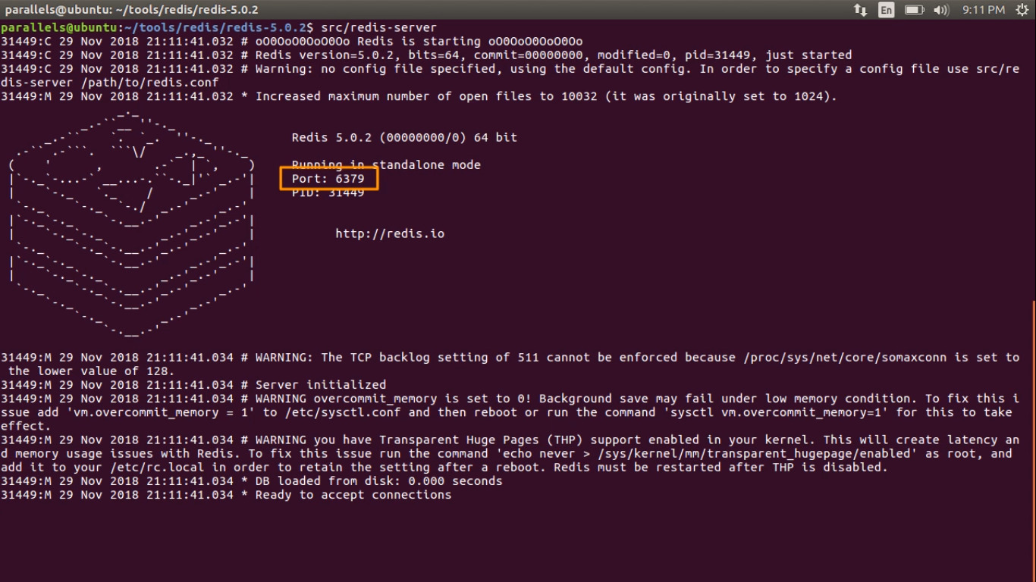

Spring boot autoconfigure the cache manager etc. In production we should use provider like Redis, EHCache. Here we will switch the caching provider to Redis.

Replace spring-boot-starter-cache to spring-boot-starter-data-redis.

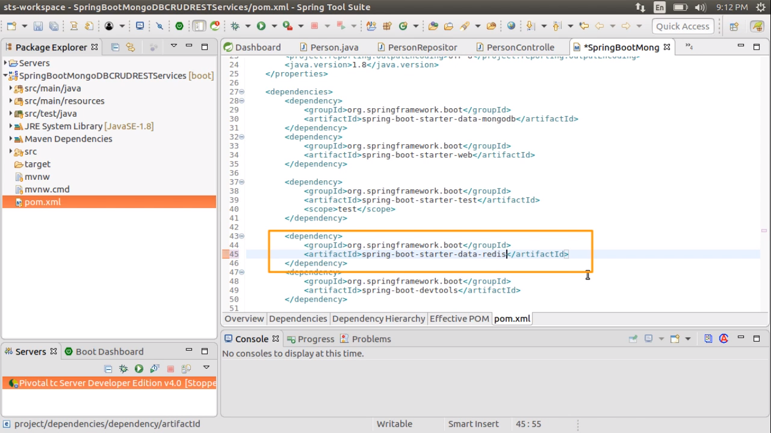

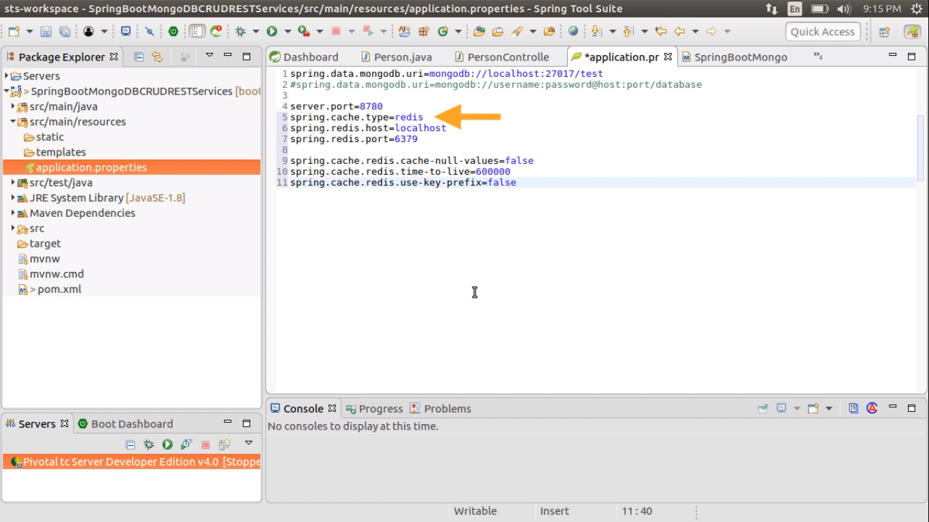

Spring.cache.redis.cache-null-values=false - to tell spring not to cache null values

For use-key-prefix=true

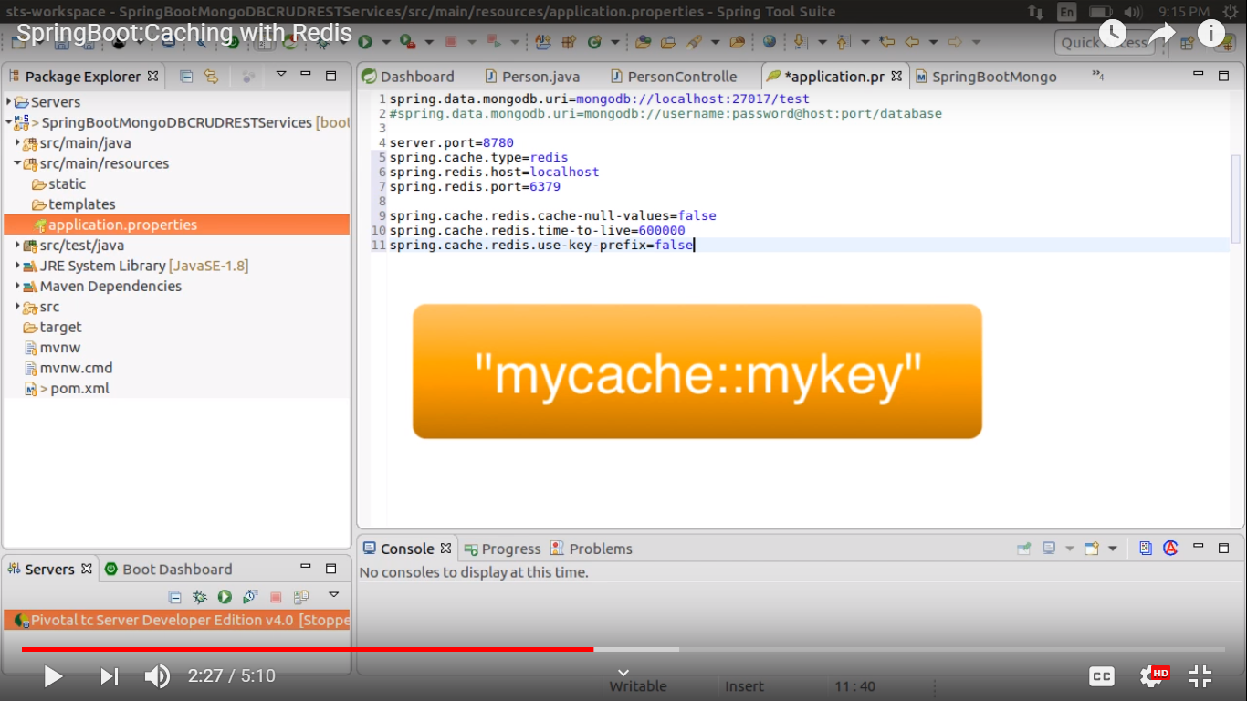

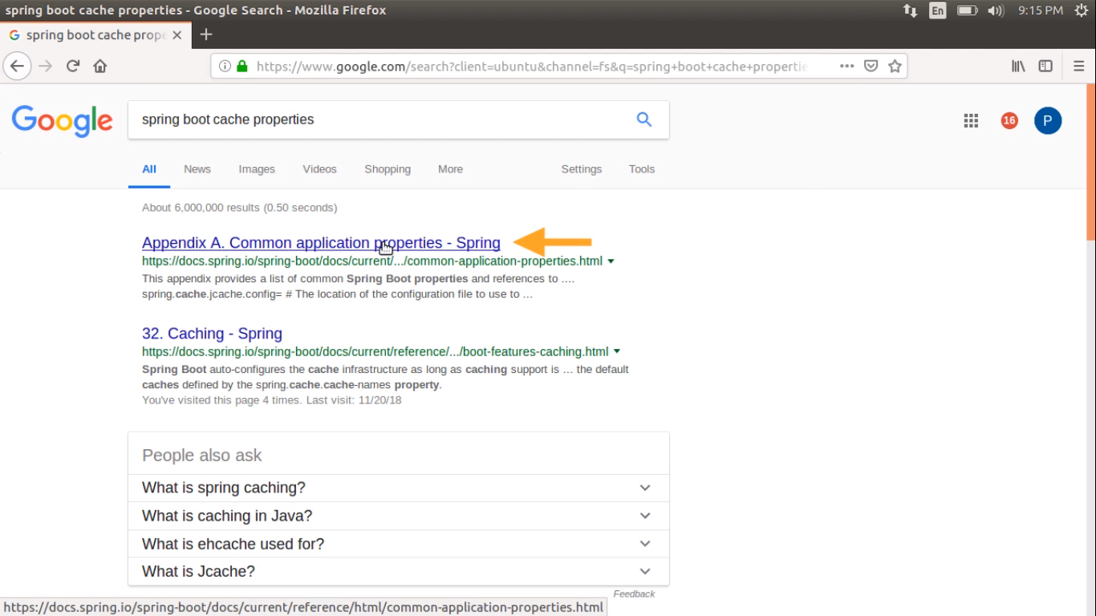

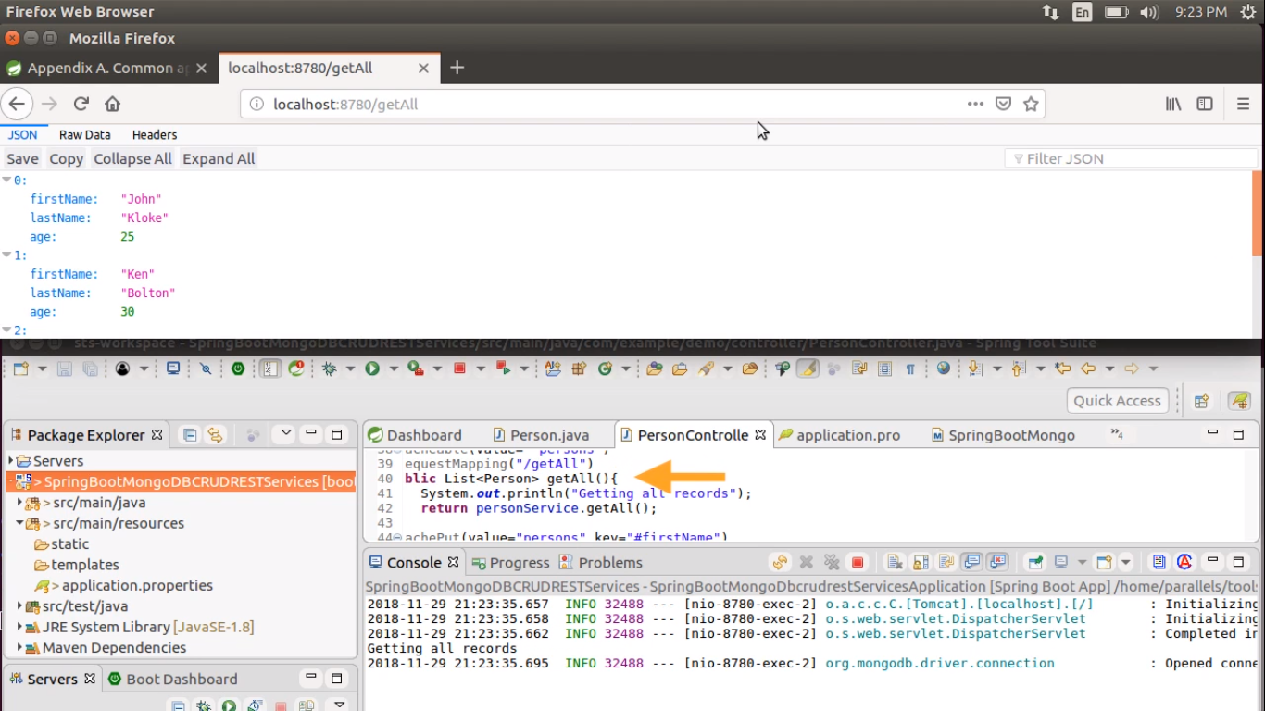

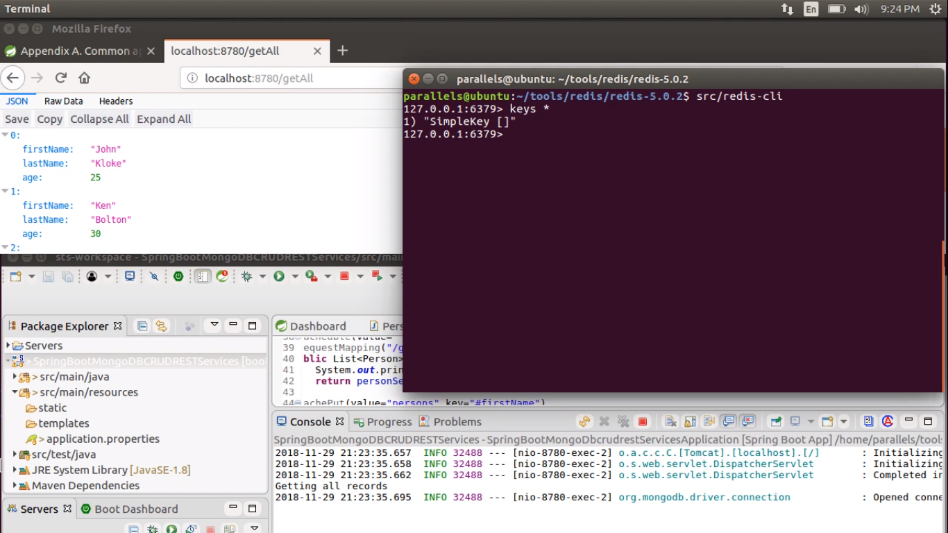

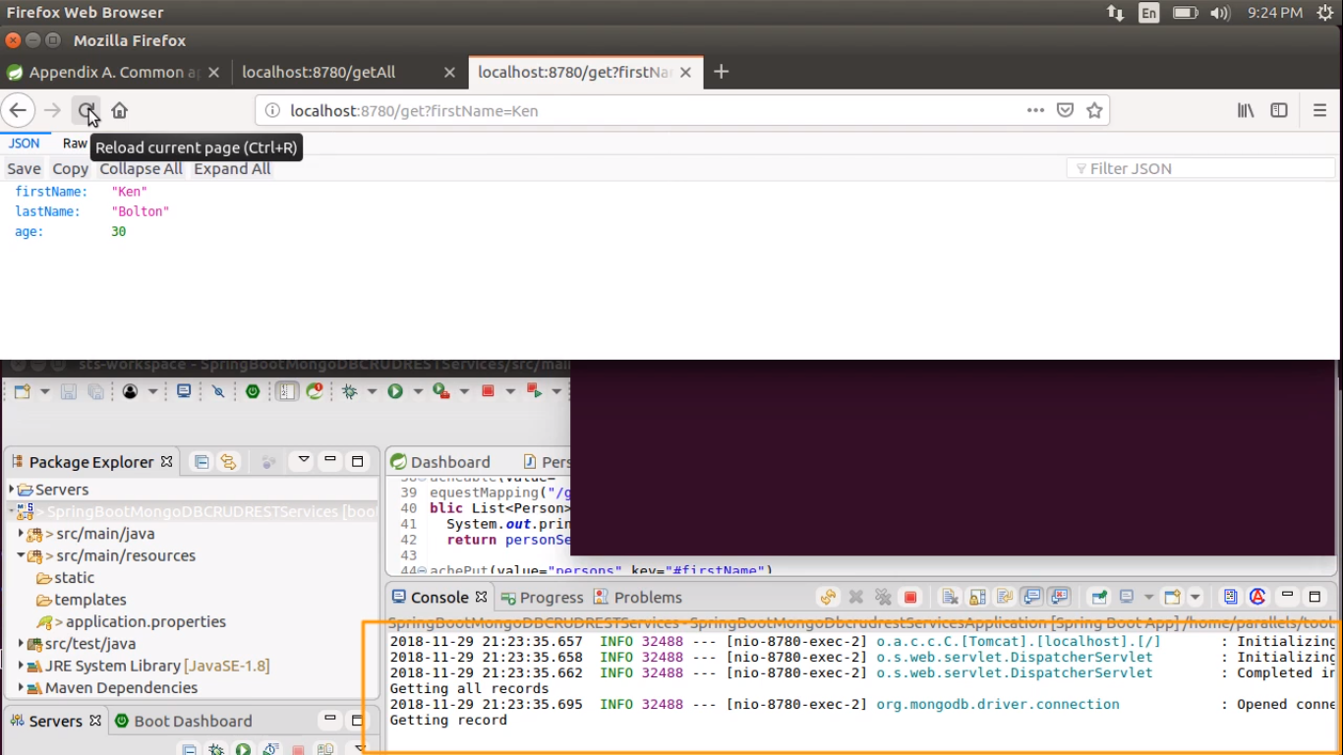

Hit the url again, it will not hit the method again.

